SULTAN KUDARAT STATE UNIVIRSITY

**REX COMPUTER STORE**

**(PURCHASED ORDER)**

**Subject**

**MIT 112**

Submitted by;

**REX LOUIS RONCESVALLES**

December, 2019

**Introduction**

A purchase order is a legally binding document between a supplier and a buyer. It details the items the buyer agrees to purchase at a certain price point. It also outlines the delivery date and terms of payment for the buyer. Purchase order computer systems have made the purchasing process more efficient and allow for better inventory and payment tracking. Purchase orders are typically used when a buyer wants to purchase supplies or inventory on account. This means the supplier delivers or ships the purchased items prior to payment, with the purchase order serving as its risk protection. Along with legal protection, purchase orders are significant in both inventory management and payment tracking. Purchase orders help suppliers compare ordered inventory to inventory shipped and on hand for accuracy.

They also allow the supplier to track when payments have been made on specific orders. Buyers hold copies of orders they place to monitor timely receipt of the items [1].

**Background**

The first pos systems emerged as American businesses evolved from barter transactions to cash. Merchants needed a way to record transactions in accounting books and also keep their money safe. [Azel C. Hough](http://americanhistory.si.edu/collections/object-groups/cash-and-credit-registers) found a way to combine these different needs into the same apparatus. The next notable POS system was the first time the term ‘cash register’ was used. The term was coined by James J. Ritty, a saloon owner in Dayton, Ohio, who was disgruntled by customers stealing money. Thus, he created a machine to count and store the money coming into his businesses. It worked a lot like a modern cash register; there were keys for entering amount increments of 5 cents and another set of keys for dollar amounts between $1 and $9. The machine kept track of individual transactions, as well as total sales. Fast forward almost a hundred years later to the 1970’s for a new definition of what is pos.

 At this time, electronic cash registers had come onto the scene, but they were limited and largely worked independently from one another. Thus, if you were a large store, you had to add the totals from each register. Then, in 1973, IBM released an actual POS system, which controlled up to 128 IBM cash registers. It was a significant advancement in technology and the first commercial application of peer-to-peer communication and a local area network. From there, the technology took off. McDonald’s introduced the first [POS system](https://ehopper.com/pos-system/) and cash registers that were controlled by a microprocessor. This made it convenient for the cashier because processing an order was quick and easy and it helped the customer by displaying each item as they ordered it. It also allowed McDonald’s to get food into customers’ mouths quicker because the cashier could press a button once the order was done being given, which sent the ticket to the kitchen, even if the customer hadn’t finished paying yet. In 1986, Gene Mosher produced a touchscreen interface for a POS system. Then, six short years later, Martin Goodwin and Bob Henry brought the technology into the modern age by creating POS software that ran on the popular Windows OS. Throughout the 90’s, the technology grew and accelerated to match the boom of computers and the Internet. Then, in the 2000’s cloud technology helped push POS systems into their next evolution. This helped drive the costs of this technology down for a variety of reasons. First, data from sales and customer information is stored in the cloud, which saves the need (and cost) of an on-site server.

Cloud-based POS saves in hardware costs in other ways too. Since it can be used with mobile devices like tablets, there are fewer upfront costs.

More and more businesses are turning to cloud and [mobile POS](https://ehopper.com/mobile-pos/) systems because of the cost savings, but also because they are more flexible and scalable to meet emerging needs [2].

**Existing Technologies**

Here are a few existing and operational Purchase Ordering System:

[**WorkPlace eProcurement**](http://www.paramounttechnologies.com/Solution_Purchasing.aspx) - WorkPlace eProcurement is a fully featured solution for automating purchases. It has multiple options for an automated and paperless procurement process. It has a centralized and web-based interface for easy access by people involved in the purchasing process. This software application also helps ensure that compliance, cost control, and reporting analytics are observed by leveraging vendor contract as well as budget enforcement [3].

[**ACCTivate**](http://www.acctivate.com/Solution/Purchasing/) - As a purchase order software, ACCTivate has a wide range of features for purchase management. It is a dynamic software application for managing requisitions of supplies, request for quotation, purchase orders, order receipts and alerts. It can give small- and medium-sized businesses control over all their purchasing processes. It has a feature called Spend Management and Budget Control which can help keep track of your budget and spending. Also, it has a functionality for stopping unauthorized purchases [3].

[**Rootstock Purchase Order Management**](http://www.rootstock.com/purchase-order-management/) - The Rootstock Purchase Order Management is a software product that you could use to easily input and track purchase orders made for direct and indirect materials and services. It has applications that are useful in the purchasing process from purchase requisitions to receipts as well as integration of the accounts payable. It also saves your vendor information and other reports pertaining to purchases, allowing you to make better purchasing decisions.

One of the special features of this program is its PO-AP Match Process. It creates Accounts Payable (AP) invoices once it matches vendor invoices with PO receipts [3].

**Statement of the Problem**

The initial problem about the Purchase Order is that it’s a manual transaction. It means that manual can be time consuming, not centralized in one location, not accessible from anywhere, approvals takes time and managing the order status can be a hassle [4].

Many e-commerce stores attempt to avoid purchase orders because they do have inefficiencies, can be tiresome to fill out, and may not be entirely necessary. For most, the largest concern is time consumption, because purchase orders typically require some time to create, check for accuracy, print, and mail to the supplier. Repetitive paperwork can cause the customers to tire. Most purchase orders are template files and only require that you change order details and the date. This means that you will be filling out repetitive documents every time you place an order [5].

**Recommendation**

Automation tools allow you to eliminate many of the cons of purchase orders. By [automating purchase order creation](https://www.skubana.com/features-e-commerce-purchase-orders/) using your inventory management tool, you can cut costs, save time, and reduce many of the disadvantages of purchase orders.

For example, you can use tools to [create automatic reorder points](https://www.skubana.com/ecommerce-order-management/), which you can use to generate purchase orders based on the SKU. When stock drops below par level, your system automatically creates a purchase order by updating standardized forms created for that purpose – so that you can review, approve, and send them to your supplier.

This does require that you have the ability to calculate and set reorder points, based on sales forecasts, so that you can reorder in time to prevent a stock out, without unnecessarily increasing inventory. However, it also ensures that you only place a new order when stock drops to a level where you need to replenish it, so that you don’t unknowingly increase stock unnecessarily by ordering on a periodic basis [5].

**Significance**

A purchase order is “a buyer-generated document that authorizes a purchase transaction. When accepted by the seller, it becomes a contract binding on both parties”. “A purchase order sets forth the descriptions, quantities, prices, discounts, payment terms, date of performance or shipment, other associated terms and conditions, and identifies a specific seller.”

The issue at the heart the importance of purchase orders is that they form a legally binding contract when “accepted by the seller.” Why is this important? Simply put, it gives the purchasing organization an increased level of control over the purchases it makes. For instance, if a product is delivered in unsatisfactory condition or, in some cases, not delivered at all, the purchasing organization has a clear record of what was expected. Remember – a purchase order sets out a well-defined set of terms including “performance of shipment,” which should include a standard of quality.

The importance of purchase orders, however, doesn’t end in the “legal” realm. Clean, clear and organized (organized!) purchase orders are key for budgeting and forecasting. An easily accessible collection of all purchase orders will give management or executives a better understanding of how much the company is spending, and on what [6].

**Capabilities**

The main capabilities of the system are to bind a contract between the supplier and REX Computer Store. Indicating types, quantity and agreed prices for product or services. The system is capable of controlling the purchasing of products and services from external suppliers. It is also capable of keeping tracks of the purchase orders weather it is not yet delivered or delivered. The user can manage its account, products, suppliers and customers. In Lameman’s term, the user can add, update or delete accounts, products, suppliers or customers. The System is also flexible, the profile of the system can be altered. The name of the system can be changed. And the system has a modest design and it is user-friendly making it easy to use and understand.

1. **USE CASE DIAGRAM**

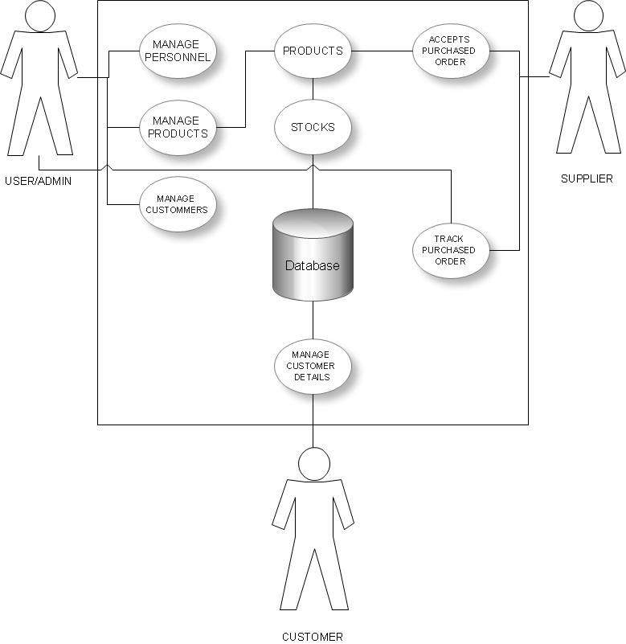

The diagram above shows the Use Case Diagram of the projects, it designs to simply determine how the projects works in terms its functionality and uses. The diagram involves three actors, the user/admin, supplier and the customer. The user/admin could manage such as personnel, products and customer details and information. The supplier could accepts purchased order, when a certain company needs its products. Also, it could trace all the transaction, whether it arrives or not. Also, the user could manage customer details.

1. **CLASS DIAGRAM**

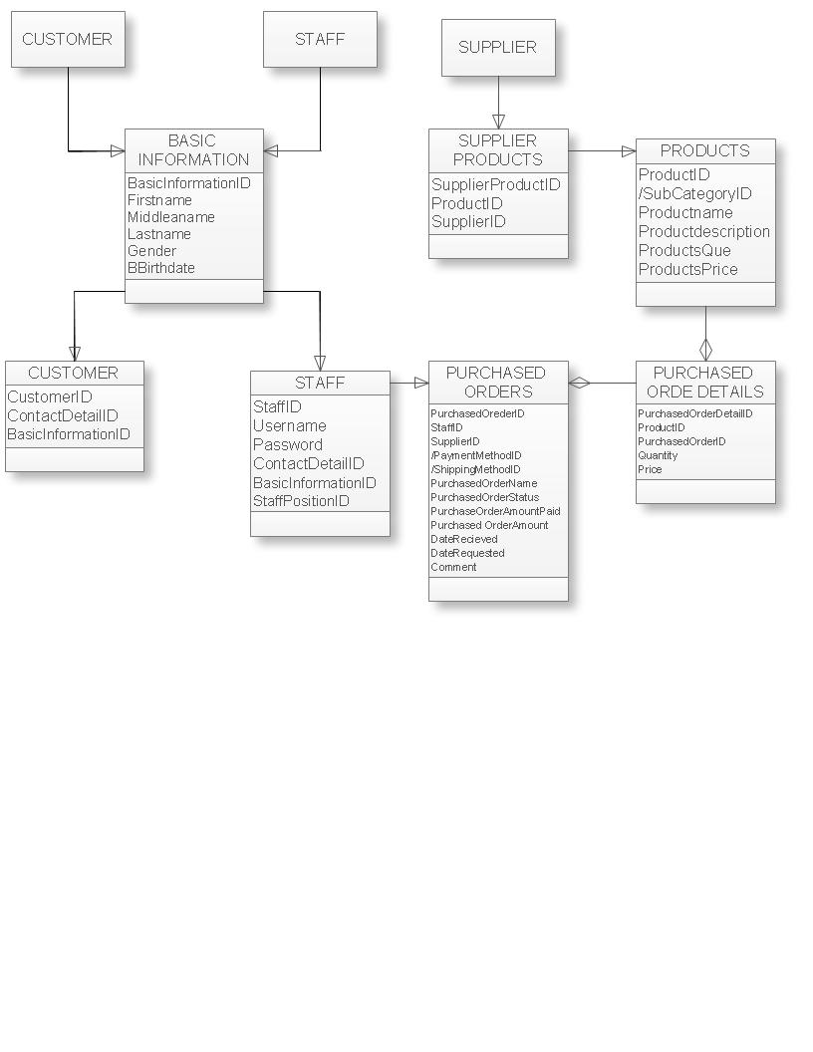

The Figure above depicts the projects’ class diagram. The project has a class of Basic Information with the attributes, that generalized of customer and staff (user). Then, the customer and staff class had been generalized of basic information. The supplier has generalized of the supplier’s products class and it generalized of the product. The products are being processed of purchased order details with the symbol of hollow diamond. All the data that are being processed in that classes are being manage by the users (staff).

1. 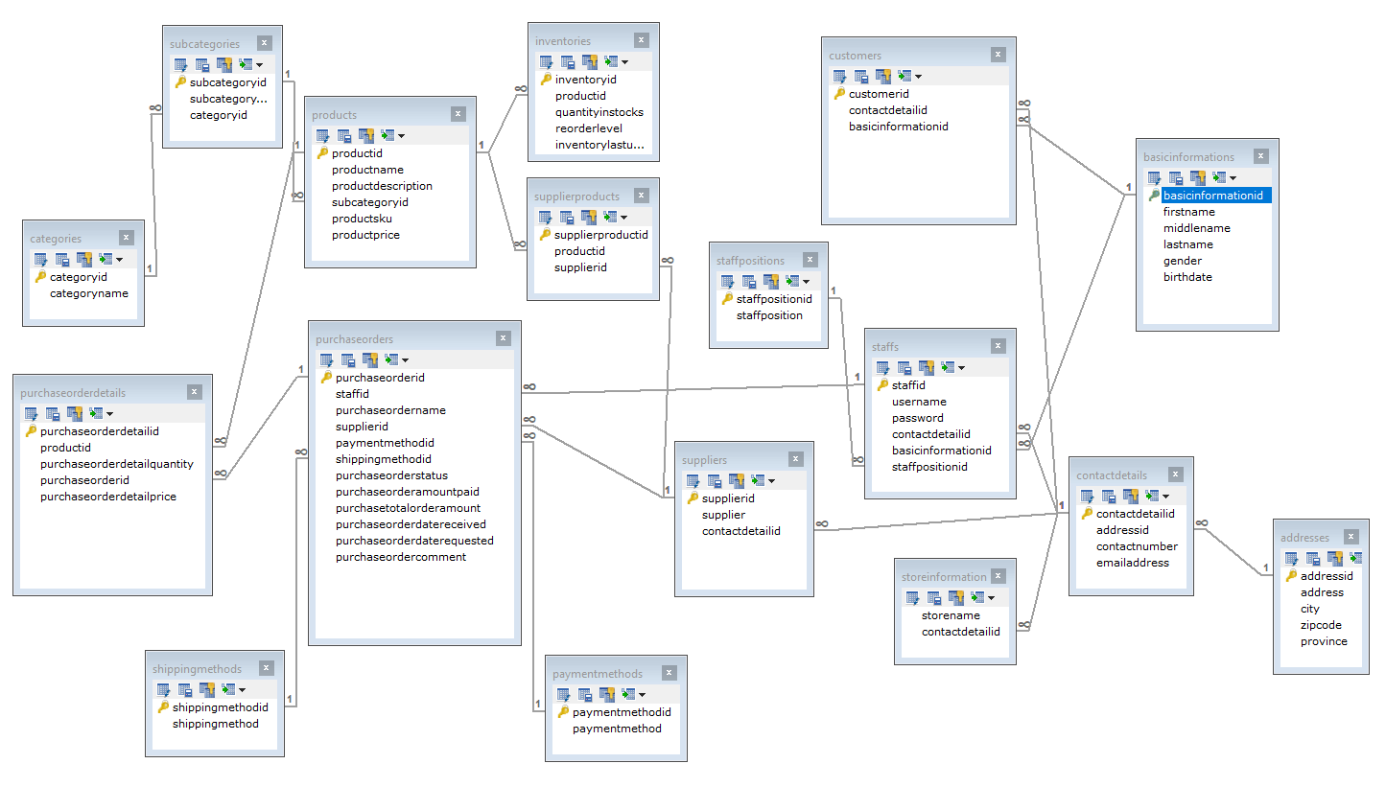**DATABASE SCHEMA**

The tables above shown all the relationships of every each of the tables, also it is shown that all tables have its primary keys and foreign keys that are being connected to other tables.

1. **USER INTERFACE**

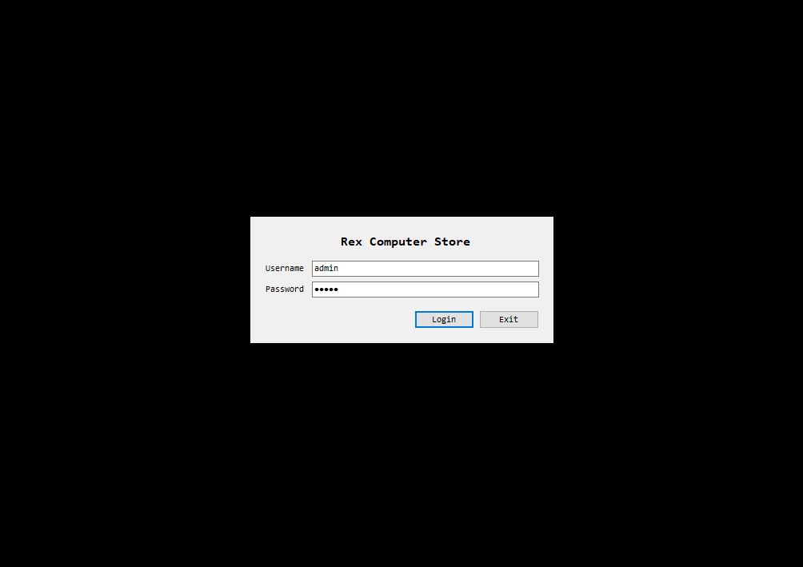

The first phase is the Log In form.

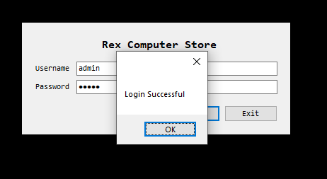

The second phase is, the time were the users enter its username and password. If it is authenticated the system prompt a message a log in successfully, else it will prompt log in failed.

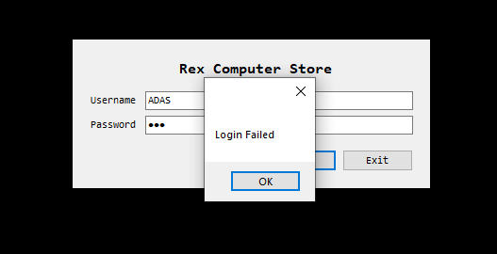

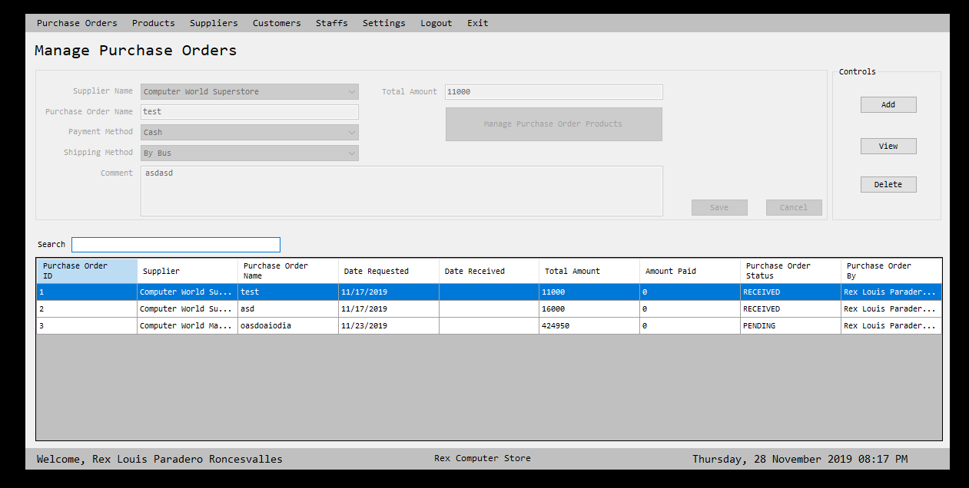

The image shows the administrator’s main form.

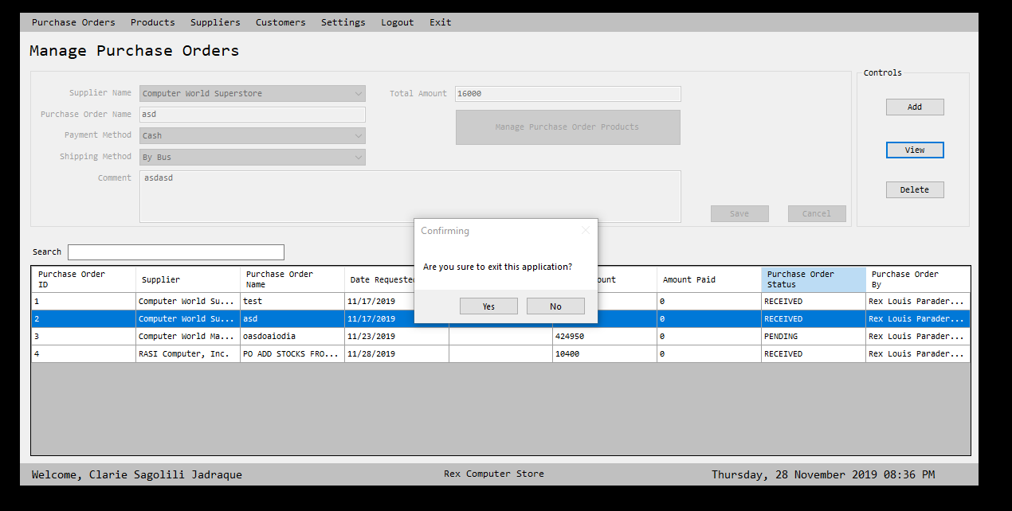

It shows that a method has been executed that, prompt a message of closing the system.

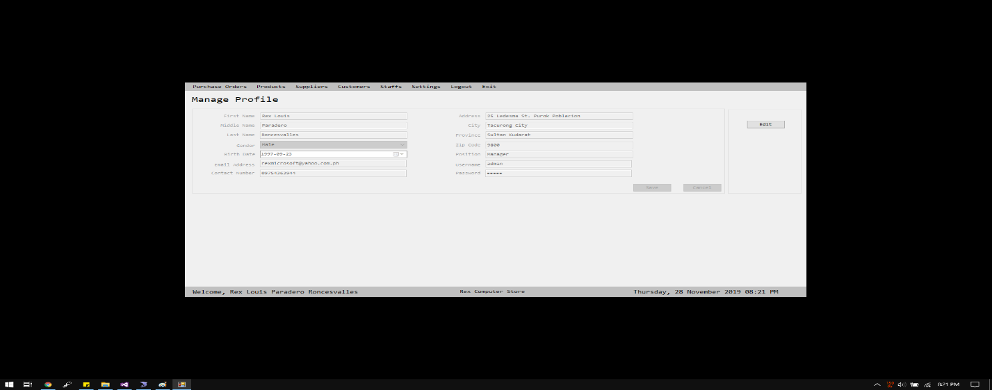

The image shows the profile’s ownership.

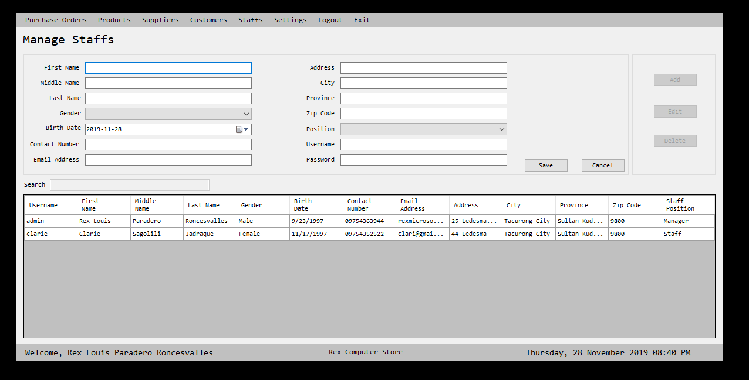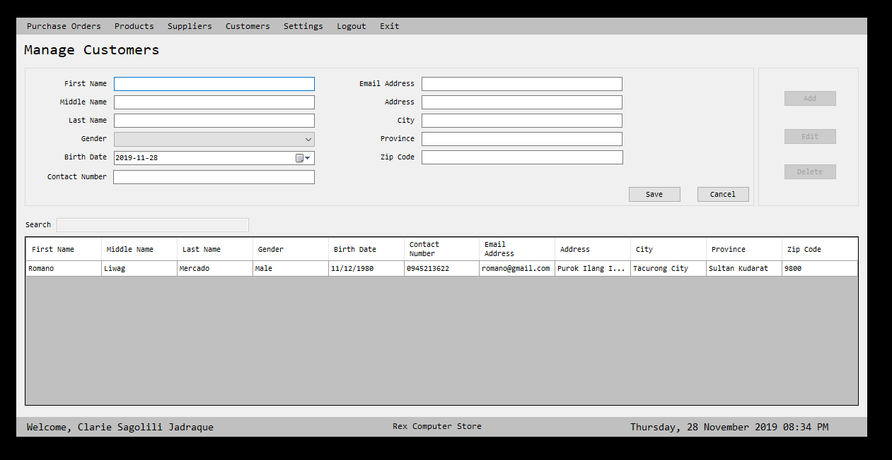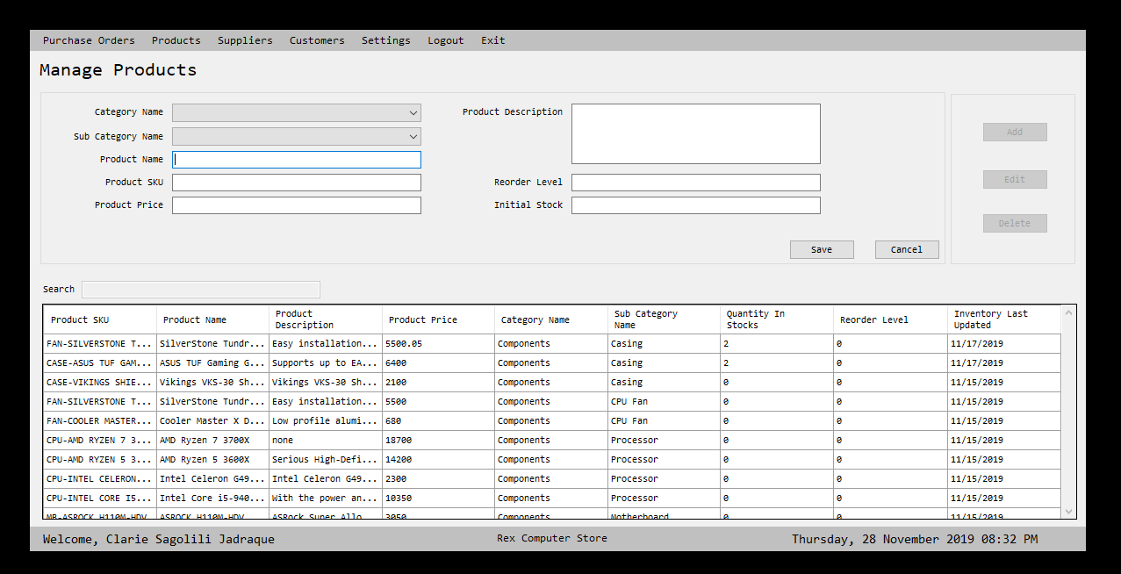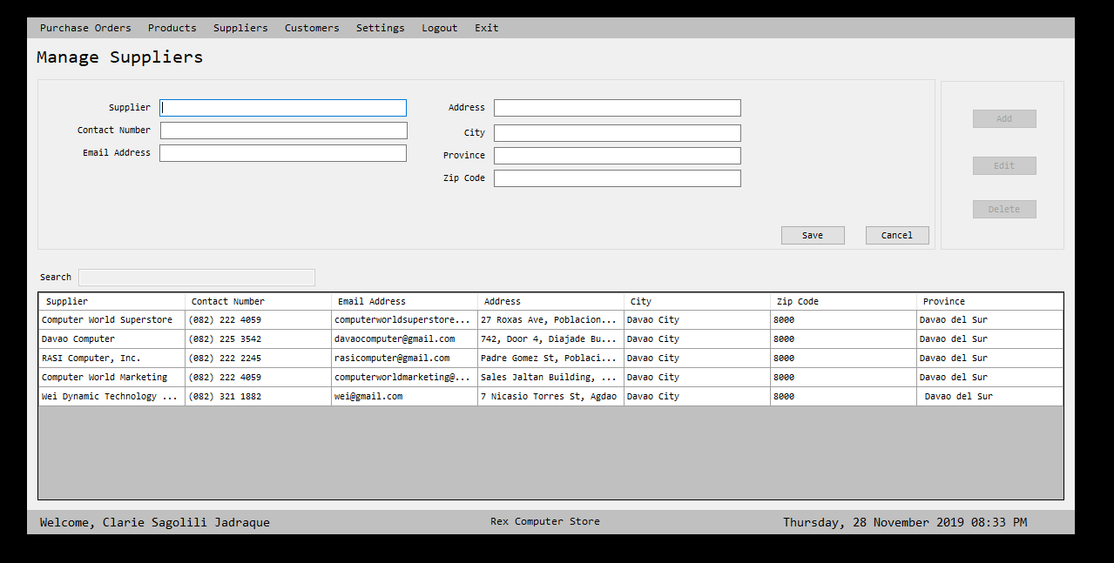The picture shows the adding of products, staffs, supplier and customers details.

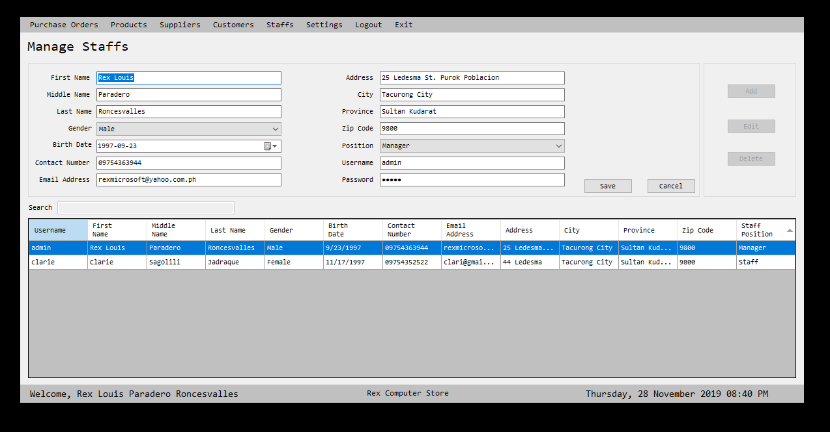

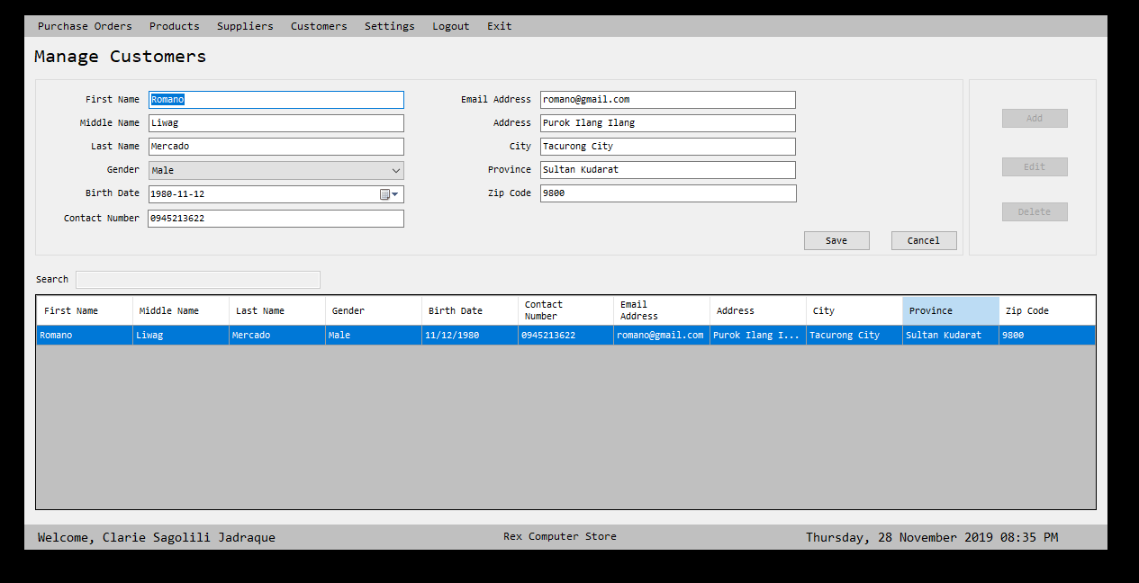

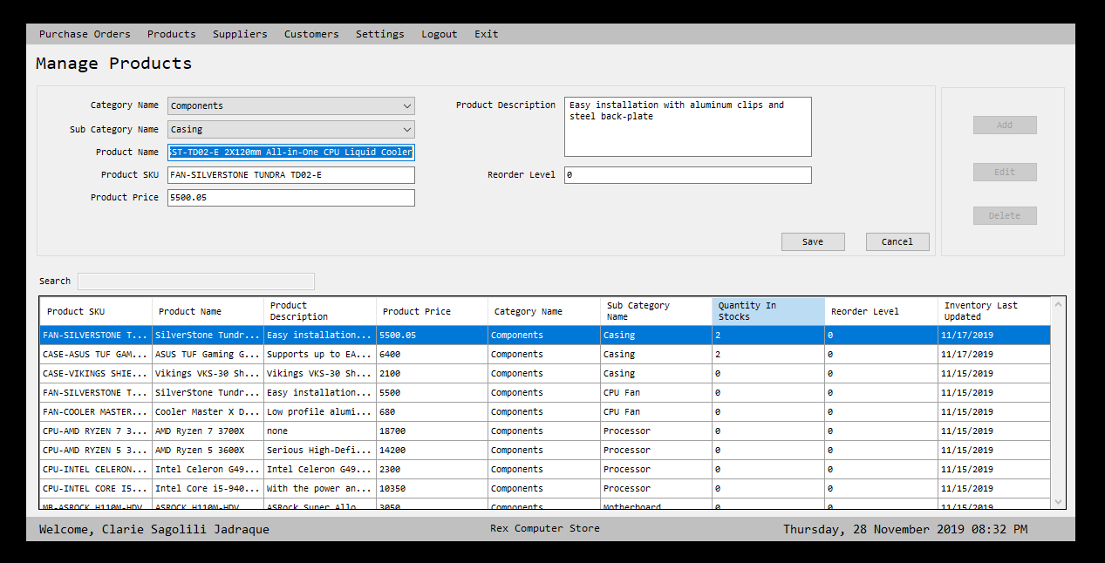

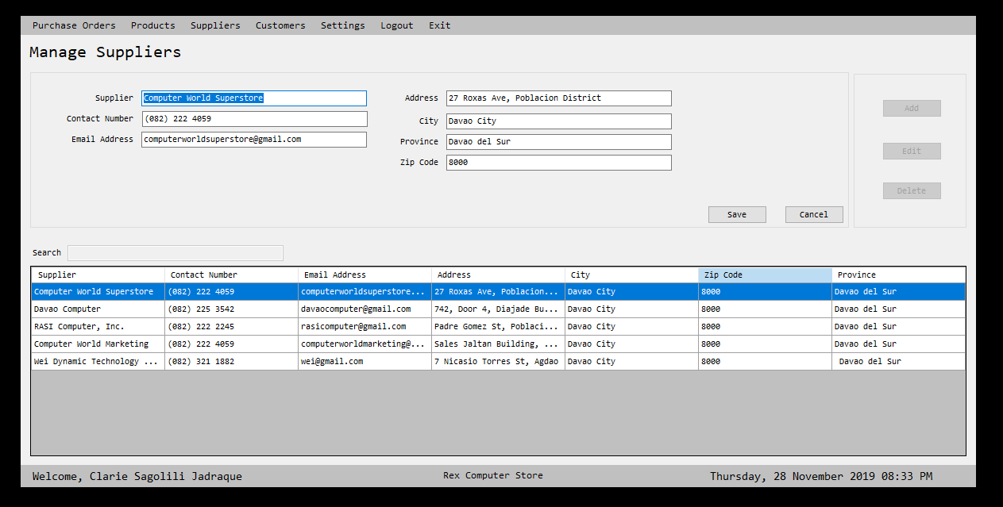

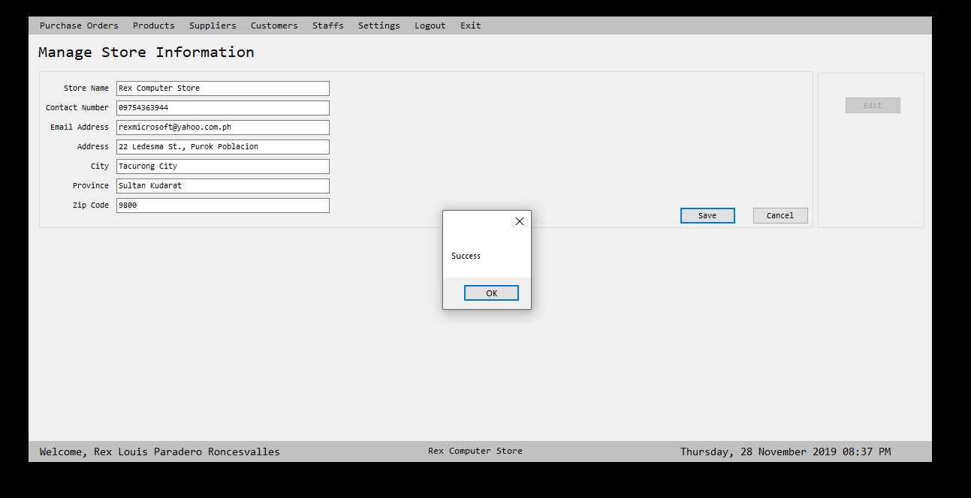

The picture shows the updating of the products, staff’s, supplier, store information and customers details.

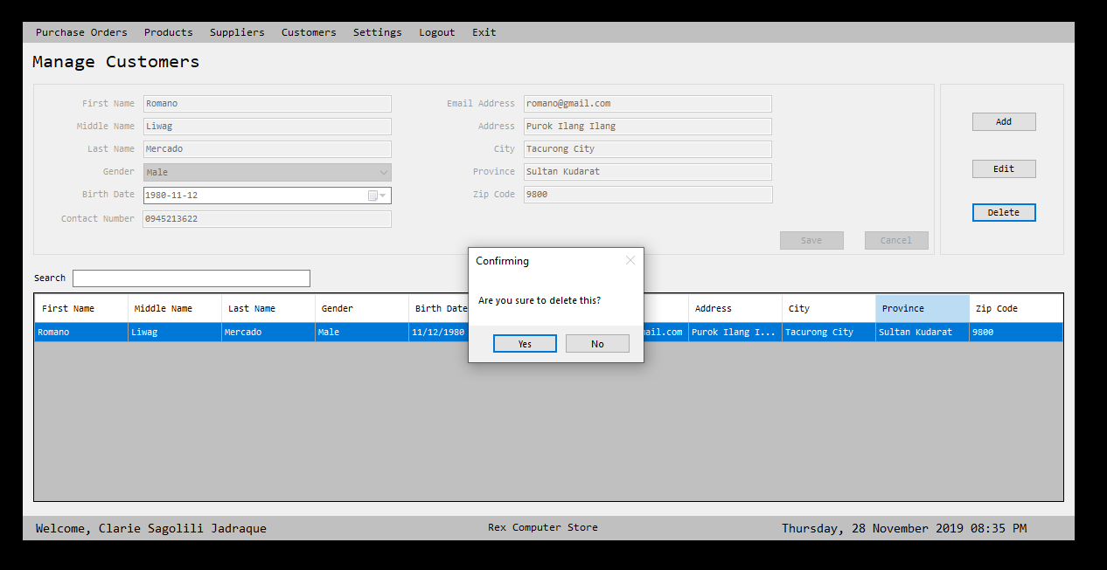

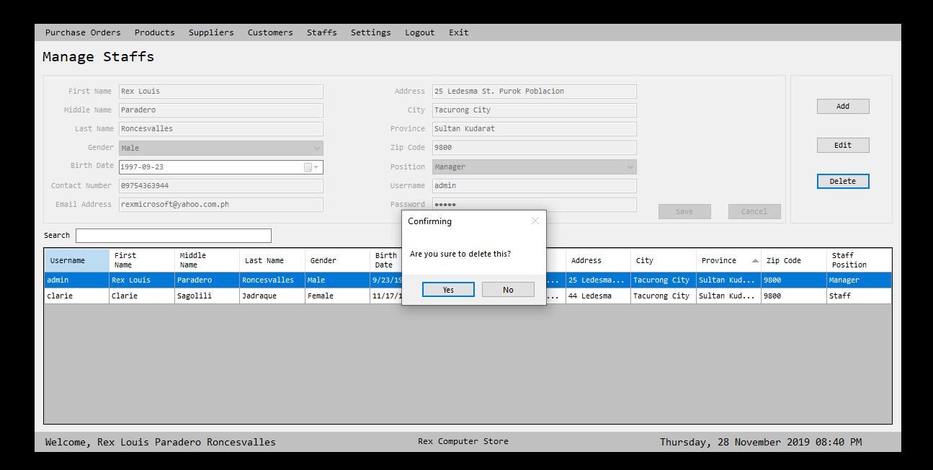

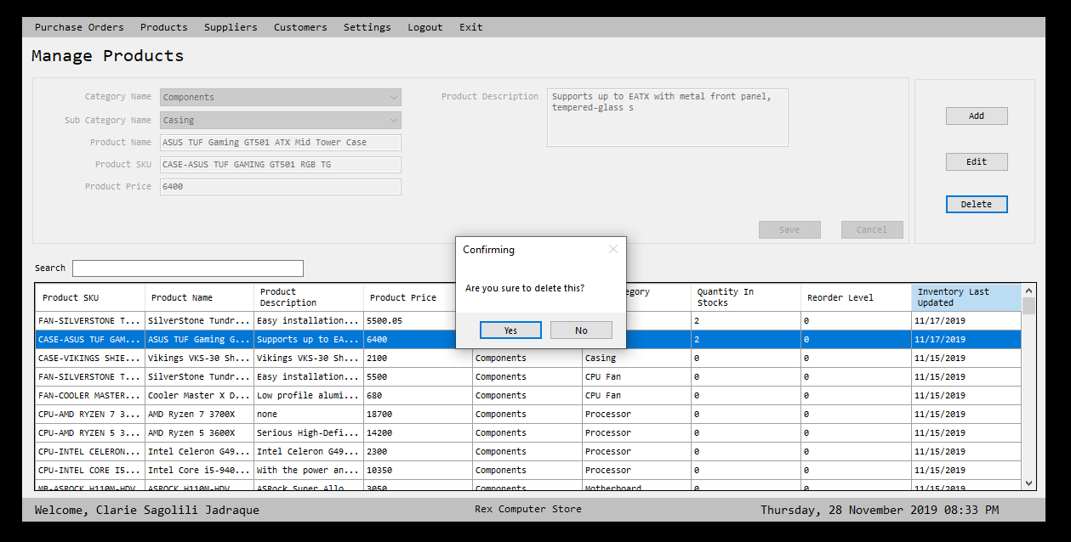

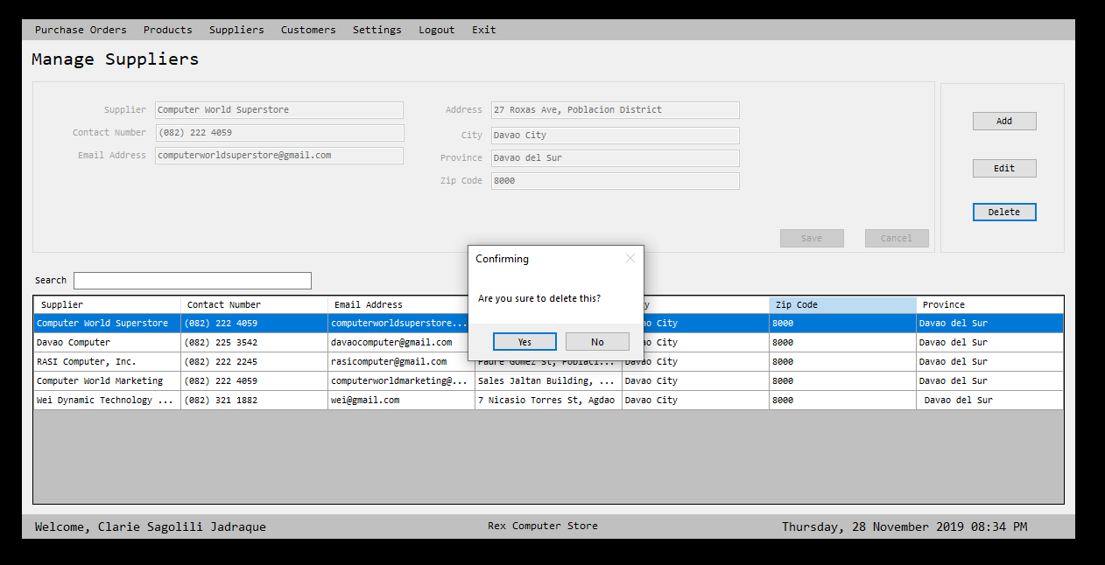

Deleting products, staff, supplier and customers details

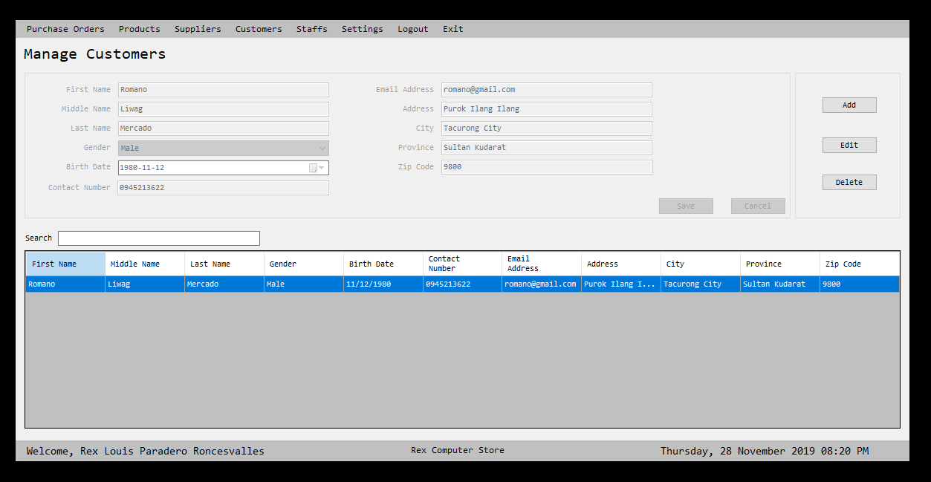

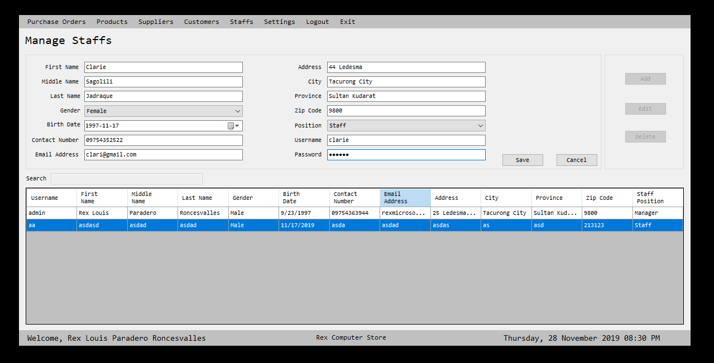

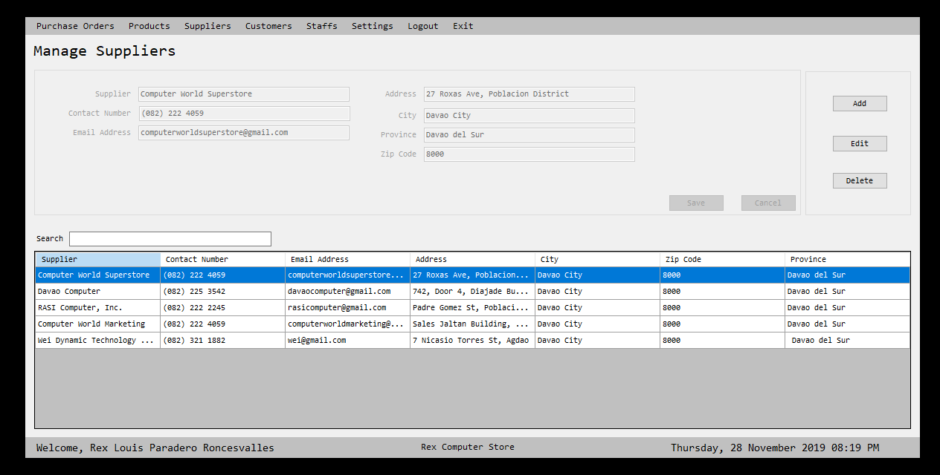

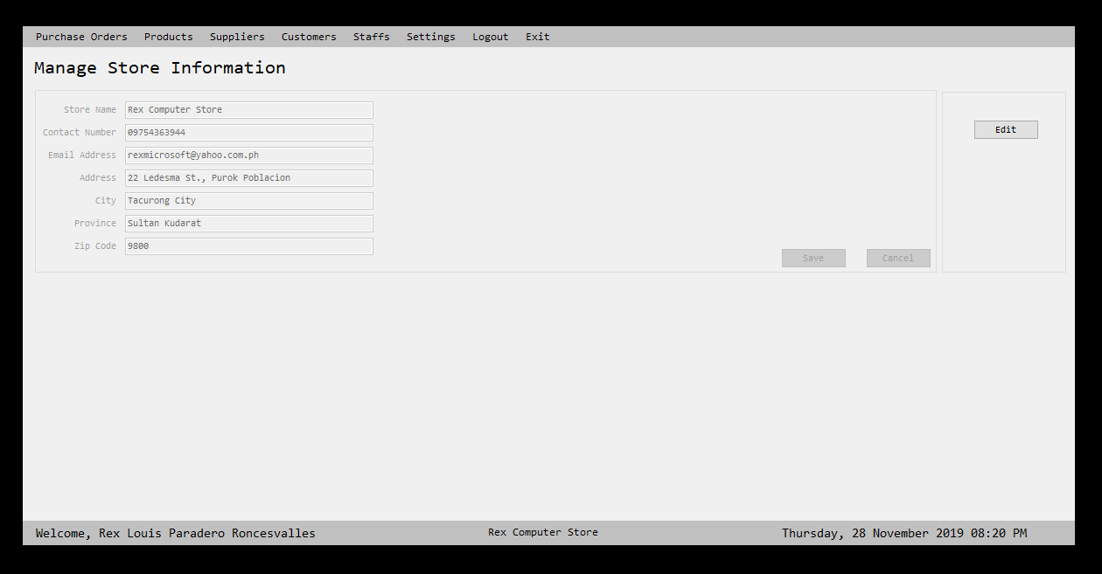

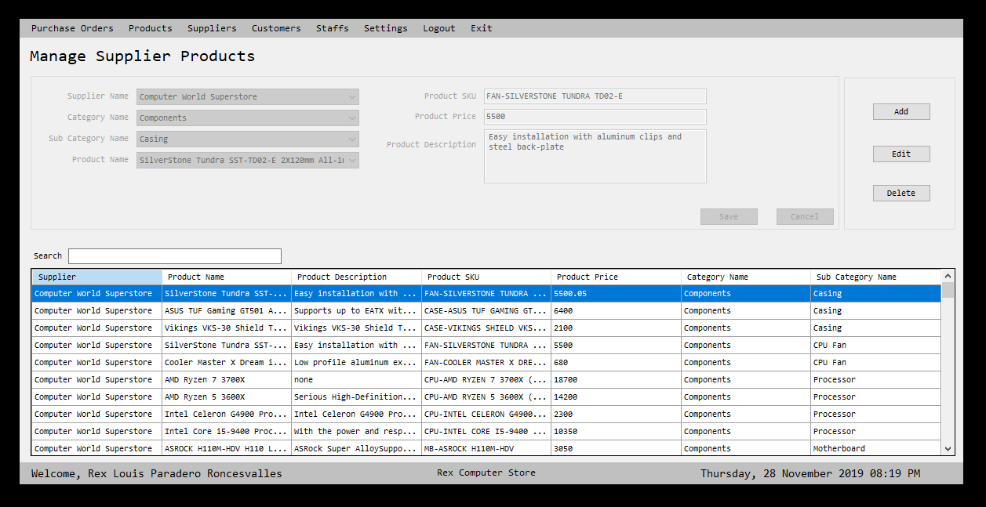Manage products, staffs, supplier, stores’ information, suppliers’ products and customers details.

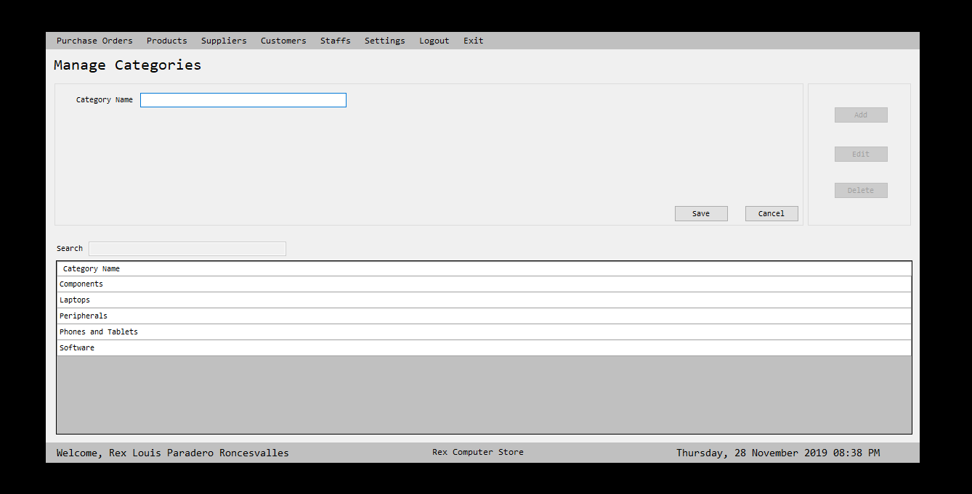

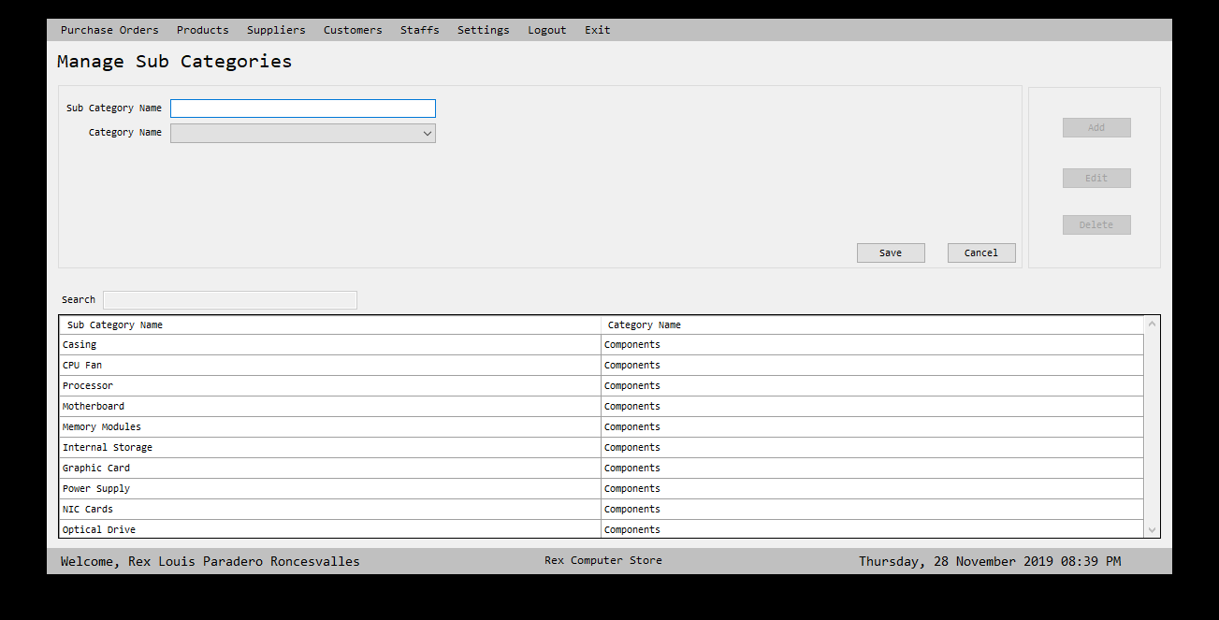The image depicts the systems could manage adding of core categories and its sub categories.

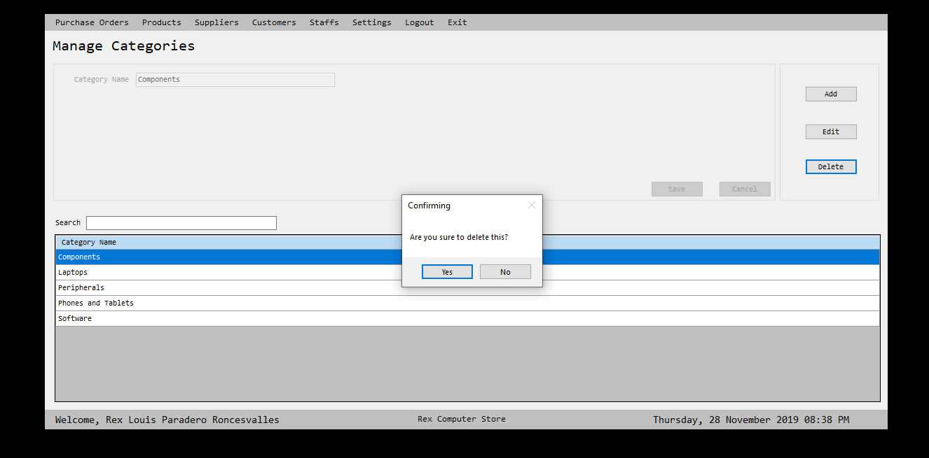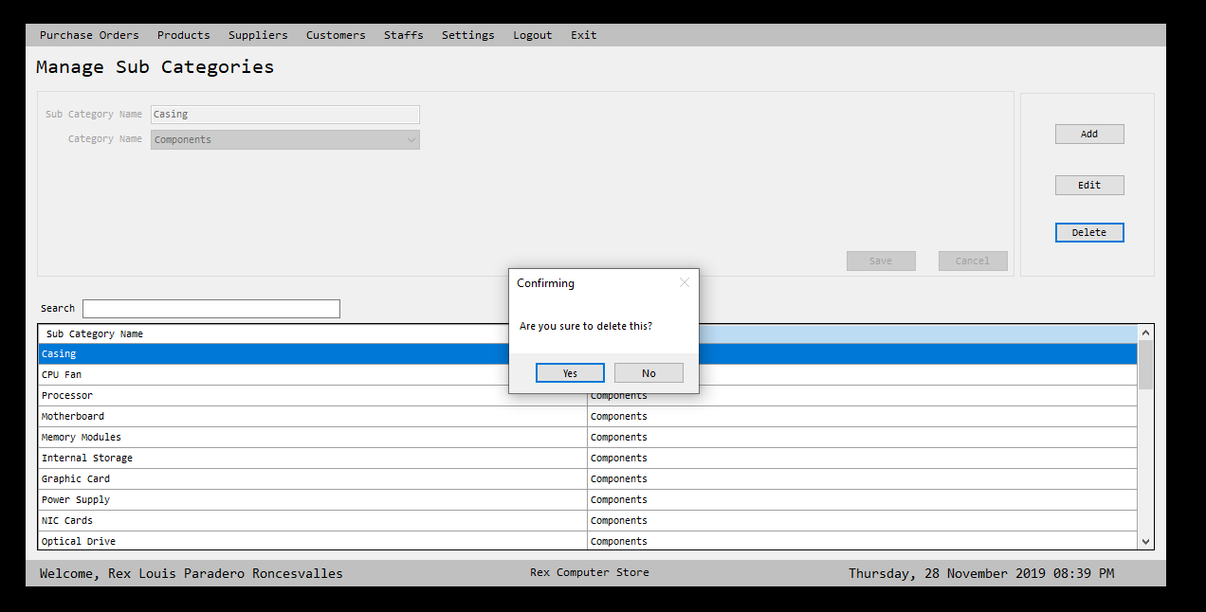

The image depicts the systems could manage deleting of core categories and its sub categories.

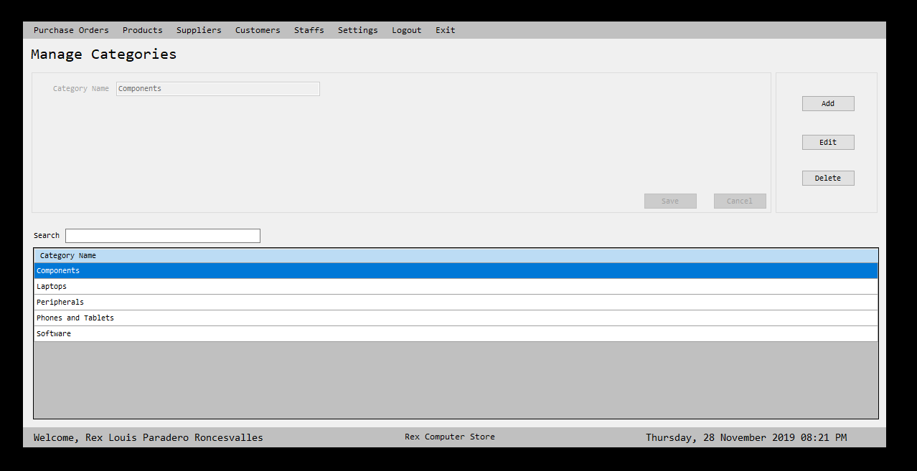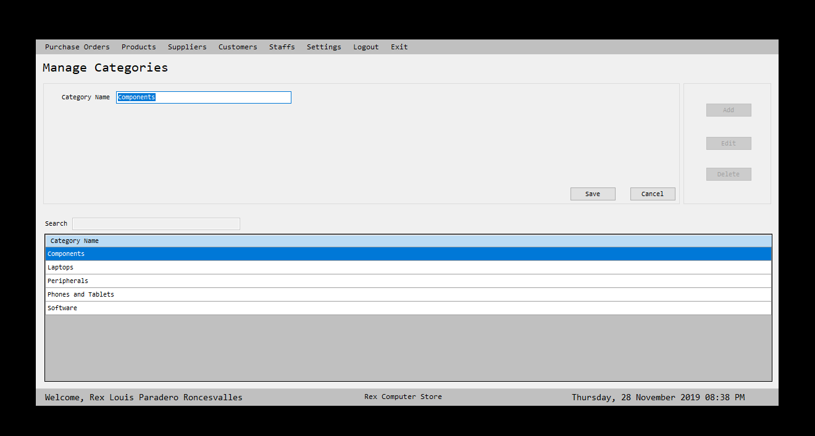

The image depicts the systems could manage updating of core categories and its sub categories.

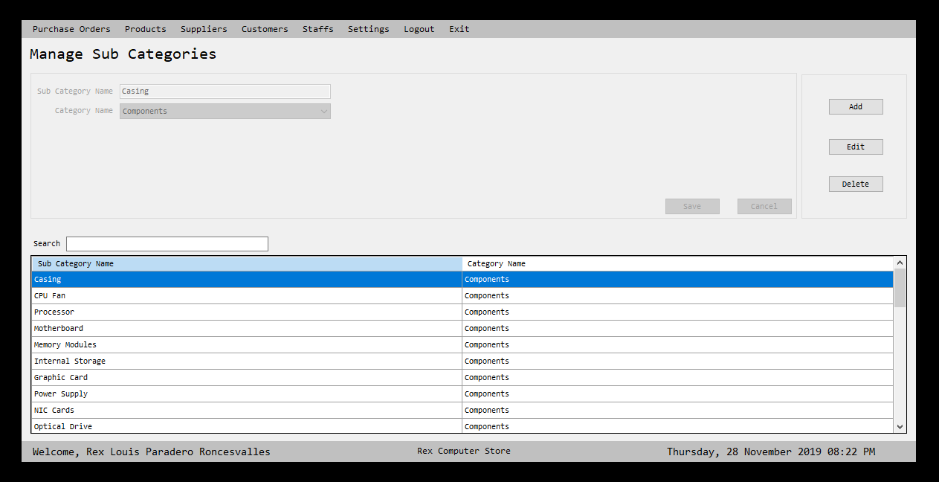

The image above shows that the system can manage of adding sub categories of products.

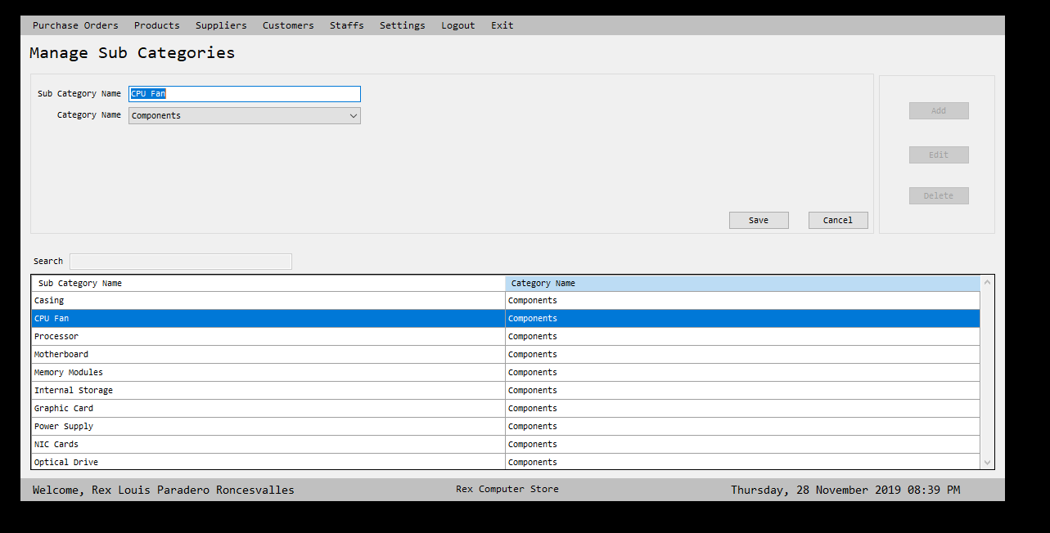

The image above shows that the system can manage of updating sub categories of products.

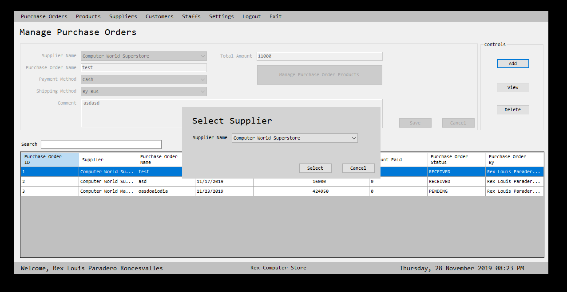

The image shows that the system proficient of creating of purchased order, which is the user selects supplier first.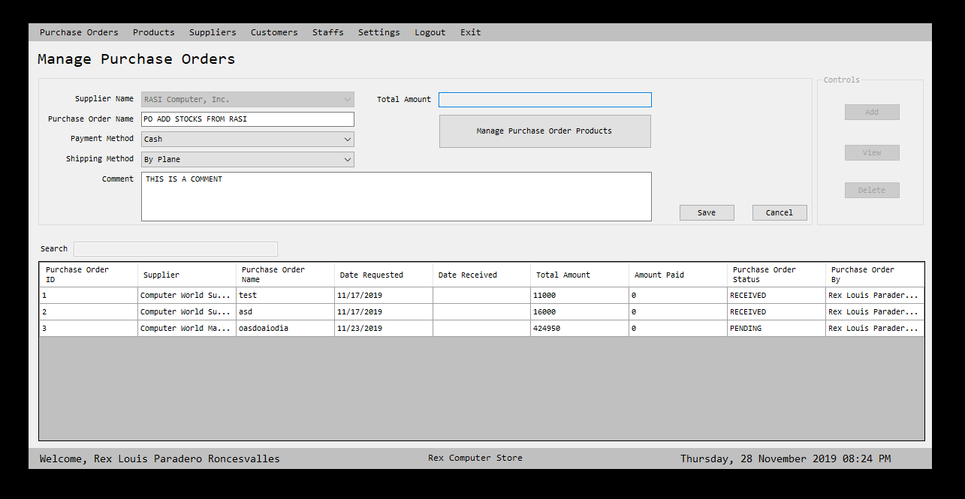

Second the user needs to fill up all the necessary information.

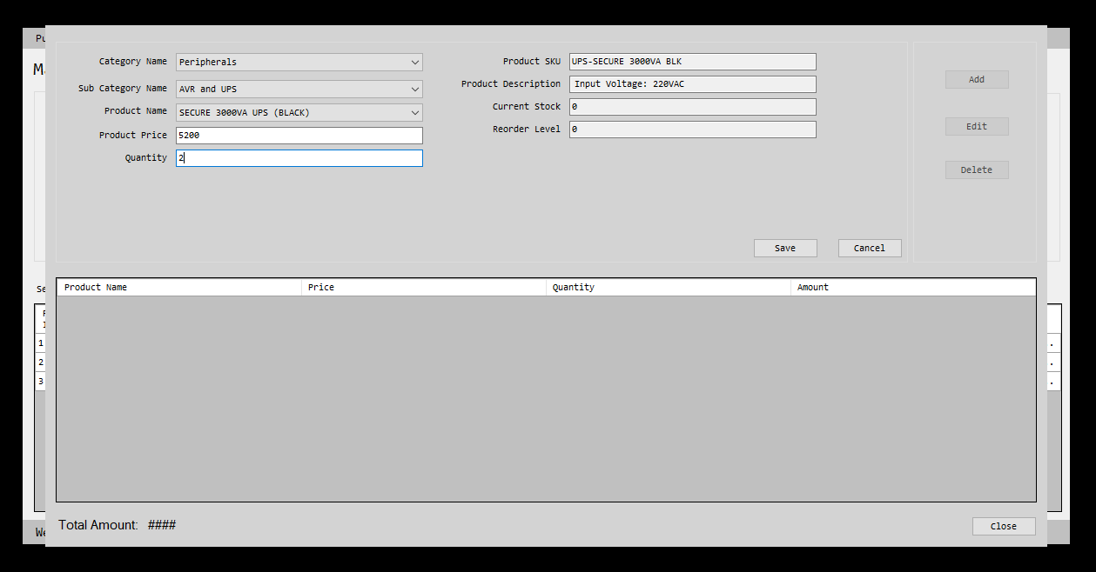

Third, the user will now add the products that are being requested.

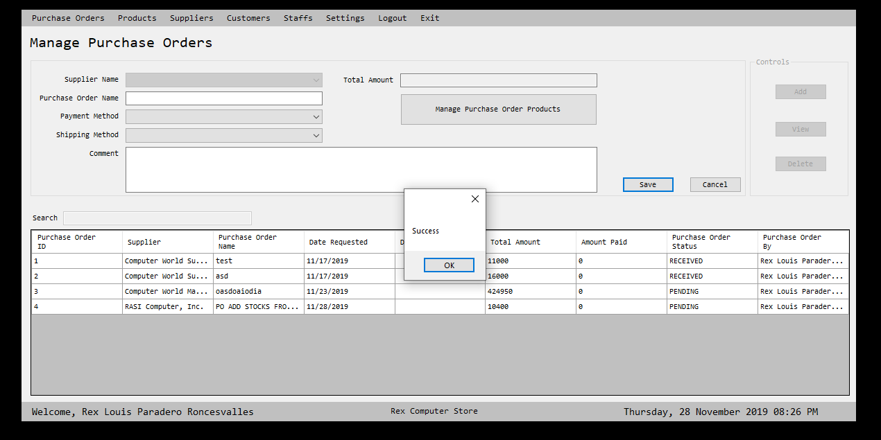

After that, the user needs to click the save button in order to include into the system database.

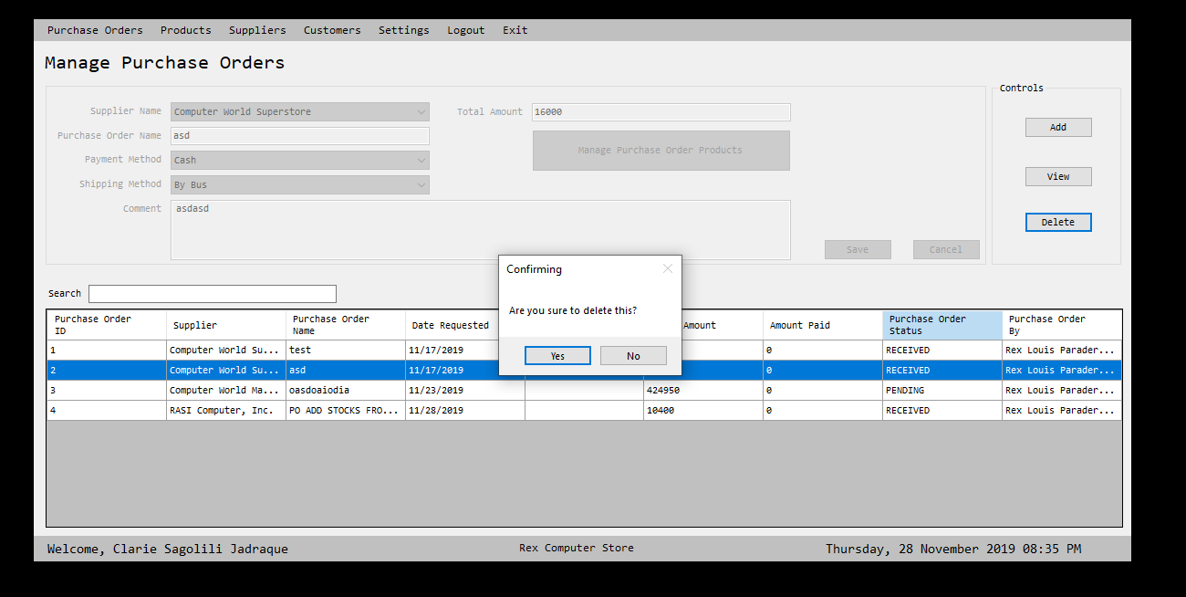

The user also could delete the unwanted purchased orders transactions.

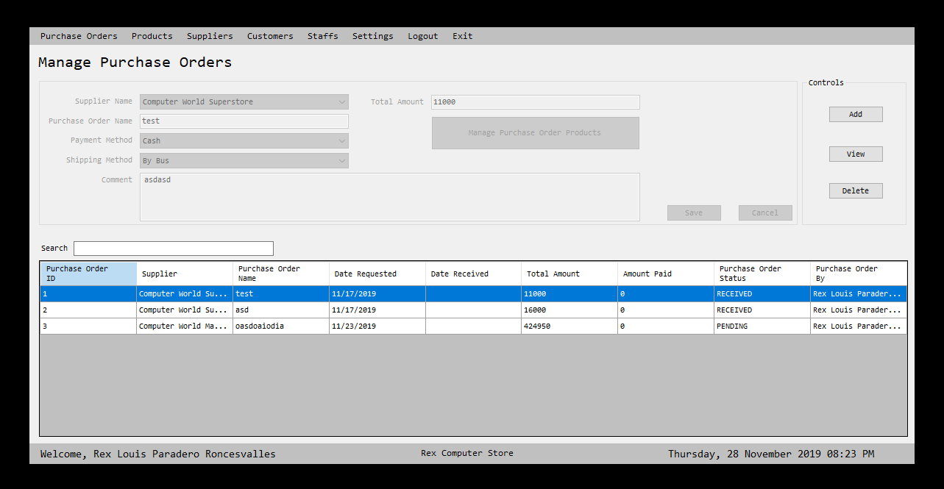

The system also capable of managing all the purchase order.

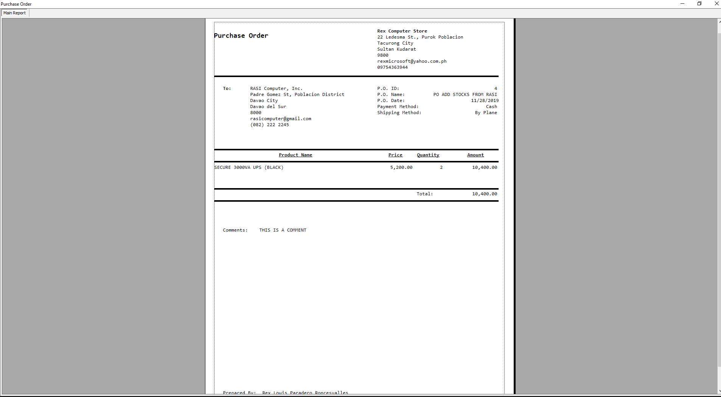

The system also has the capability of printing of purchased order for documentary.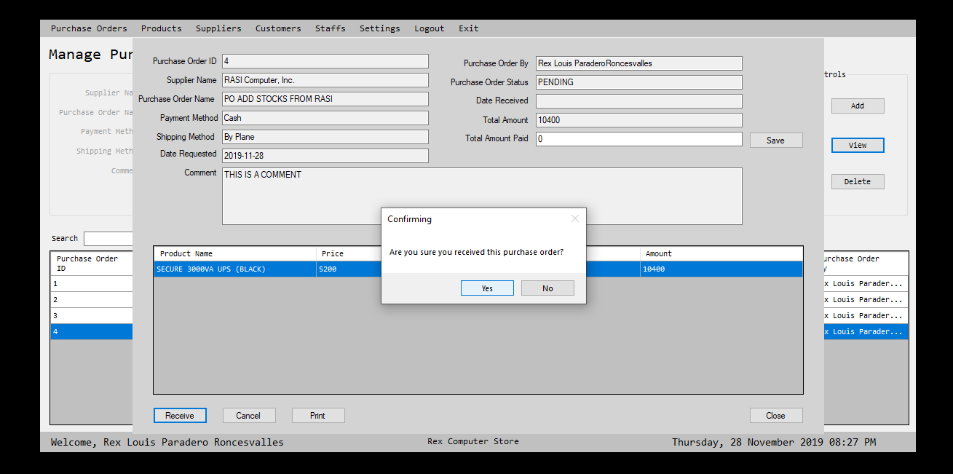

The image shows the system could manage of receiving an order transaction.

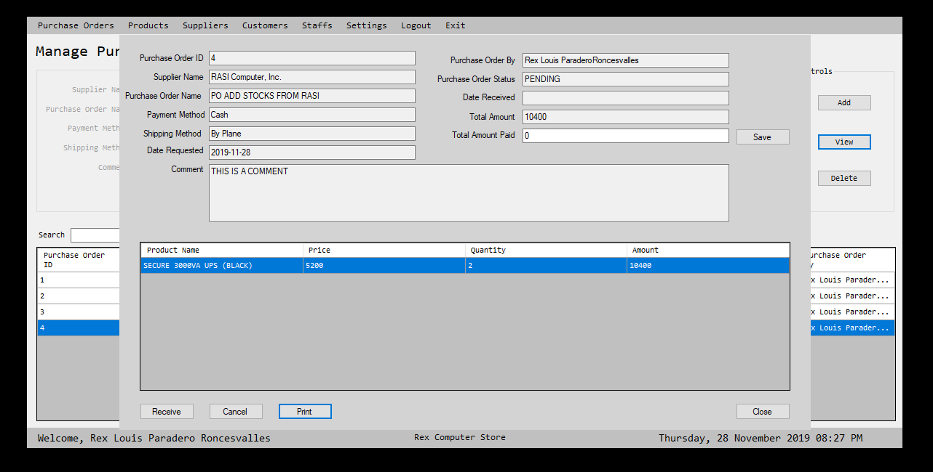

The system could view a specific transaction.

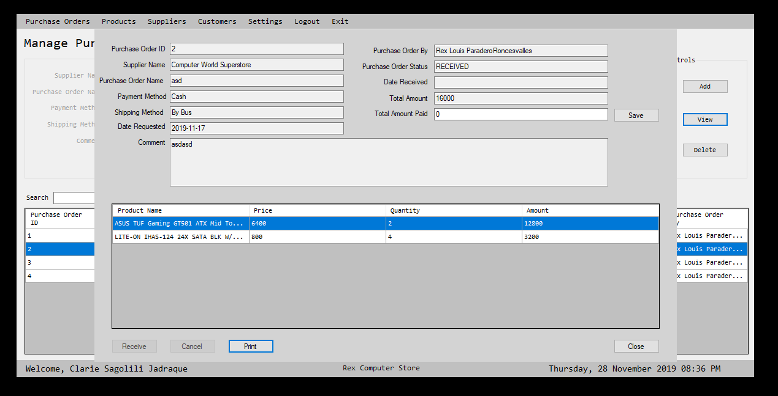

**RESULTS AND DISCUSSION**

After the development of the project, the results showed that the developed system satisfied all the objectives. That utilized all the traditional methods of purchasing ordering system, it helps all the user to lessen their task and time consuming would be obliterated, as well as, it promotes the new technologies into the traditional one.

Moreover, it was been evaluated of some users, that garnered its user satisfactory and pleasing environment, easy to used and understand. The accuracy of updates calculations of every purchasing orders, releasing and receiving, total amount and its units is also been appraised generating of reports is also acknowledgeable since it was an easy way of creating of documentation.

Based on the project results conducted, it is best to be that the application should be used in to the real world. Since the generation now, is more on innovation and creating new features of applications.